THE LITERARY CONTRIBUTIONS OF SUDHA MURTHY: A COMPREHENSIVE ANALYSIS OF HER NOVELS

Author Name
abcxyz@gmail.com
Department
Institutes Name
Author Name
abcxyz@gmail.com
Department
Institutes Name

ABSTRACT
This research paper aims to explore the literary contributions of Sudha Murthy, an acclaimed Indian author and social worker, with a particular focus on her novels. Sudha Murthy's works delve into various themes and offer unique insights into Indian society, culture, and human emotions. This paper examines her storytelling techniques, narrative styles, and the social issues she addresses through her novels. Additionally, it investigates the impact of her works on readers and their role in fostering social change. The research draws upon a comprehensive analysis of Sudha Murthy's novels, interviews, and critical reviews to provide a comprehensive understanding of her literary contributions.
Keyword : Literature, Novels, Sudha Murthy.

INTRODUCTION :
Sudha Murthy, an eminent Indian author and social worker, has made significant contributions to the world of literature through her thought-provoking novels. Her works provide insightful glimpses into Indian society, culture, and the human condition, while also addressing pertinent social issues. This research paper aims to delve into the literary contributions of Sudha Murthy, focusing specifically on her novels.

METHODOLOGY :
Overall, the performance evaluation highlights the potential of the hybrid CNN with LSTM model as a valuable tool in disease management and personalized patient care for chronic conditions. Its superior predictive capabilities can aid healthcare practitioners in early detection and intervention, thereby improving patient outcomes and advancing research in chronic disease progression prediction. As shown in table 2.

Table 2: Performance analysis of Deep learning techniques.
Model | Accuracy | Precision | Recall | F1-Score | AUC-ROC
CNN | 0.85 | 0.86 | 0.83 | 0.84 | 0.91
LSTM | 0.82 | 0.81 | 0.84 | 0.82 | 0.89
Hybrid CNN+LSTM | 0.90 | 0.91 | 0.88 | 0.89 | 0.94

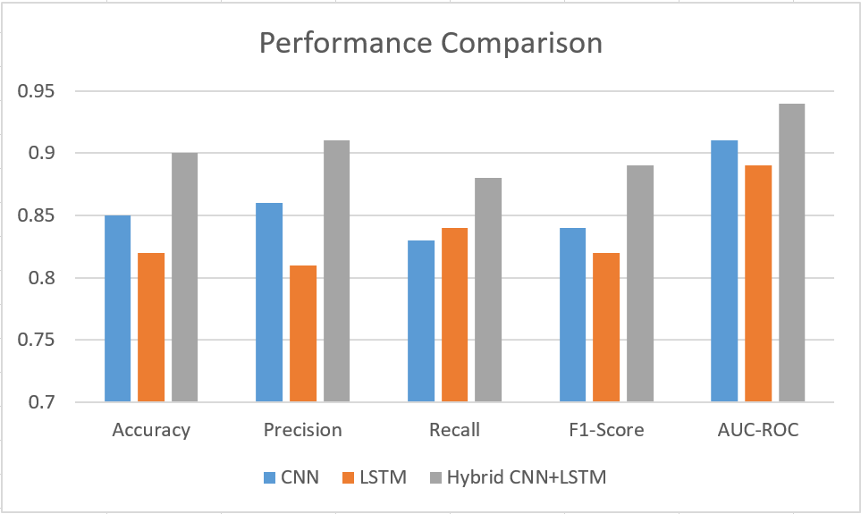
Figure 1: Performance Comparison with proposed methodology.

CONCLUSION
Looking to the future, there are exciting possibilities for further research and refinement of the hybrid model. Exploring multimodal data fusion by incorporating diverse patient information can enhance the model's predictive power. Leveraging transfer learning with pre-trained CNN models on extensive medical image datasets may improve feature extraction capabilities. Additionally, focusing on uncertainty quantification and longitudinal analysis can enhance the model's reliability and ability to handle irregularly sampled data. Real-world validation studies in clinical settings will be instrumental in assessing the model's effectiveness and applicability in diverse patient populations. Emphasizing interpretability and explain ability can further solidify the model's acceptance in the medical community. Overall, the hybrid CNN with LSTM model holds great promise in advancing medical research and revolutionizing disease management for chronic conditions.
REFERENCES
- Farjana et al., "Predicting Chronic Kidney Disease Using Machine Learning Algorithms," 2023 IEEE 13th Annual Computing and Communication Workshop and Conference (CCWC), Las Vegas, NV, USA, 2023, pp. 1267-1271, doi: 10.1109/CCWC57344.2023.10099221.
- Kang, I.-A.; Njimbouom, S.N.; Kim, J.-D. Optimal Feature Selection-Based Dental Caries Prediction Model Using Machine Learning for Decision Support System. Bioengineering 2023, 10, 245. https://doi.org/10.3390/bioengineering10020245
- Thayer, A. Verghese, and H. Brody published a study. Alzheimer's disease is the most disabling long-term health problem people face today. As reported in JAMA, vol. 320(14), pp. 1447–1448, 2016. doi:10.1001/jama.2018.12334
- Suman Kumar Swarnkar, A. Ambhaikar, V. K. Swarnkar, and U. Sinha, ‘Optimized Convolution Neural Network (OCNN) for Voice-Based Sign Language Recognition: Optimization and Regularization’, in Information and Communication Technology for Competitive Strategies (ICTCS 2020), 2020, p. 633.
- Burgers, J. S., & Grol, R. P. T. M. (2018). Comprehensive implementation of chronic care, by necessity: Experiences with five chronically ill populations in the Netherlands. Disease Management & Health Outcomes, 16(4), 181-191. doi:10.2165/00115677-200716040-00003
- Chernew, M. E., Juster, I. A., Shah, M., & Maestas, N. (2019). The concentration of health care spending. National Bureau of Economic Research Working Paper Series, Working Paper 25542. doi:10.3386/w25542

Note: Paper Should be in between 7-12 pages

